**MongoDB—NoSQL Document Store—Employee Training Score Analysis**

**Project Solution**

1. Install Mangodb and create a database “employee” and collection “training”
2. Import Json file with employee data into MongoDBdb

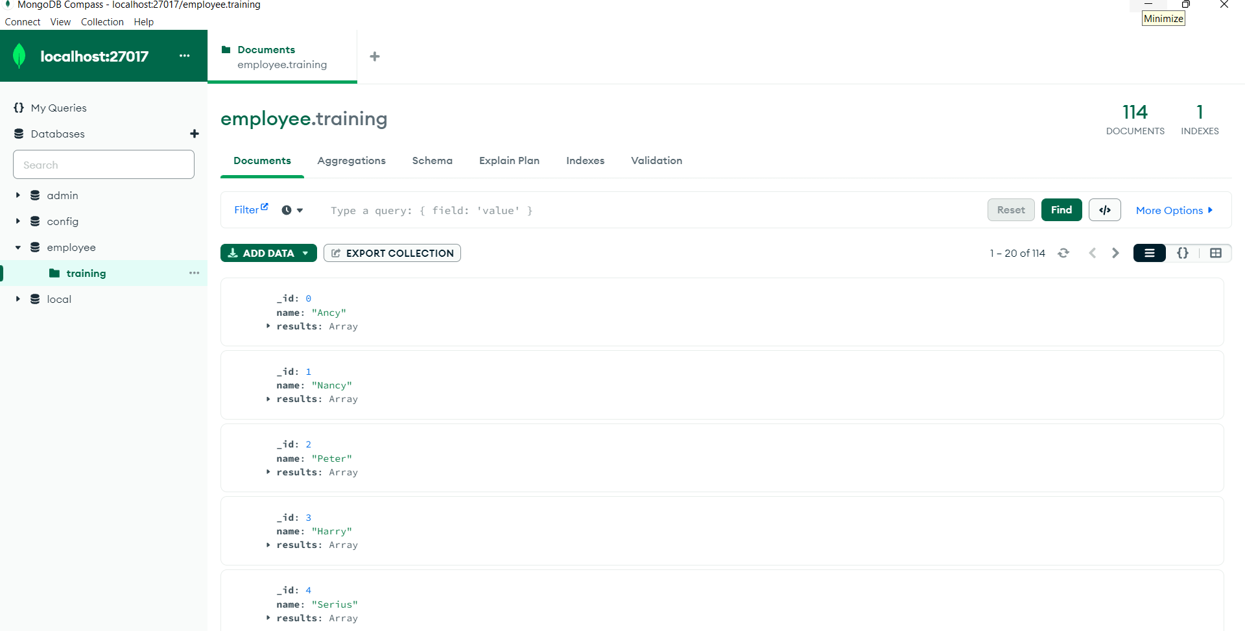

1. Install eclipse and write a java code to answer requested questions

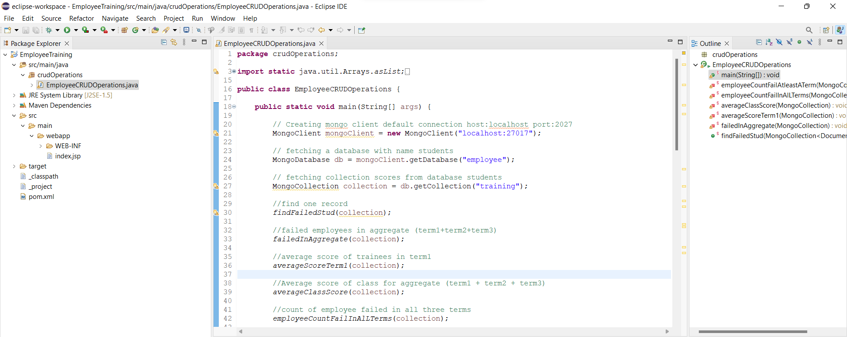

Tasks

* Find count and percentage of employees who failed in term 1, the passing score being 37
  + a-Number of students failed in exams : passing marks 37 : 91
  + b-Percentage of students failed in exams : passing marks 37 : 79 %
* Find employees who failed in aggregate (term1 + term2 + term3)

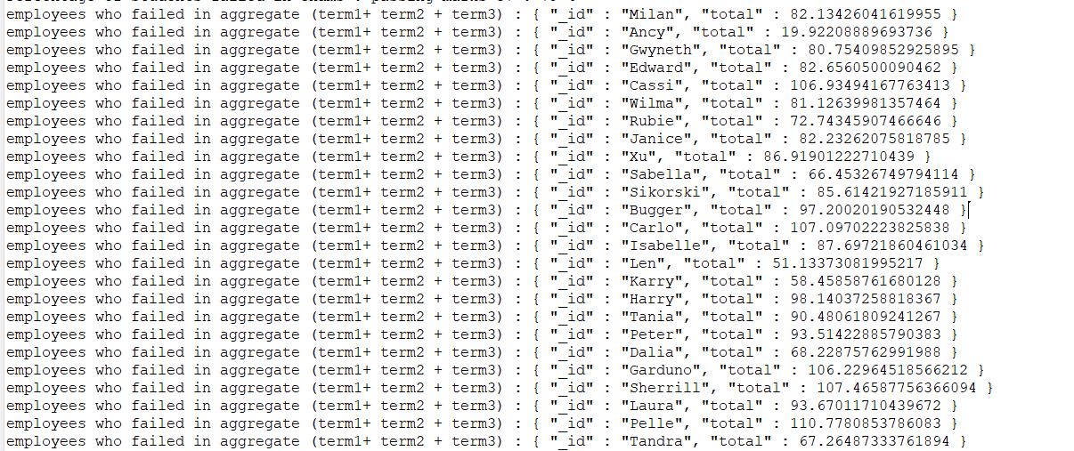

* Find the Average score of trainees for term1

Average score of trainees for term1 : { "_id" : null, "Average" : 51.55520892536331 }

* Find the Average score of trainees for aggregate (term1 + term2 + term3)

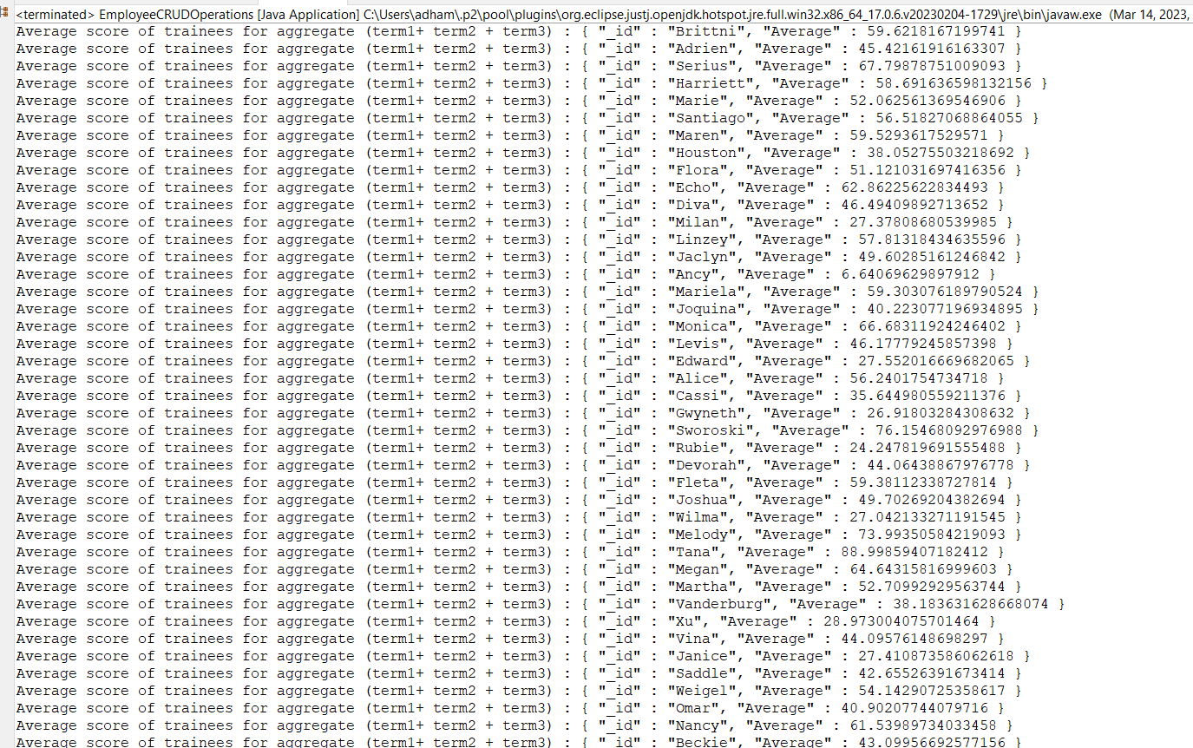 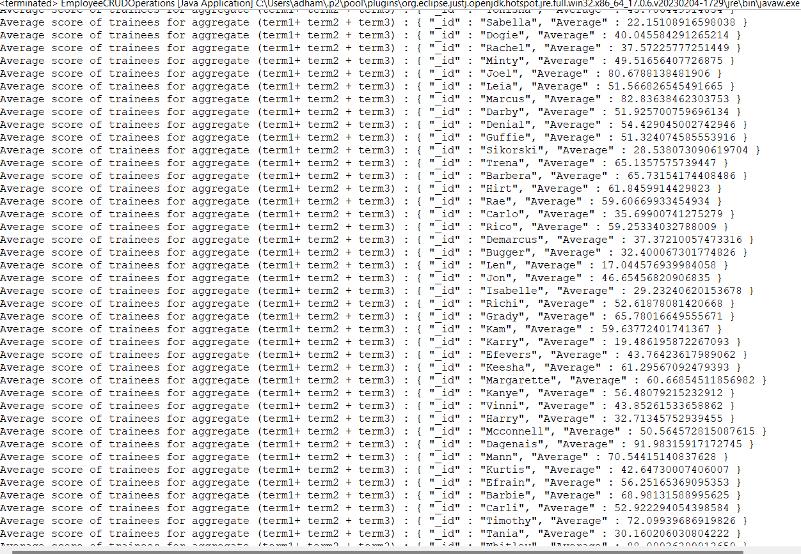

* Find the number of employees who failed in all the three (term1 + term2 + term3)

Count of employees failing in all terms : 6

* Find the number of employees who failed in any of the three (term1 + term2 + term3)

Count of employees failing in either of the terms : 91